
Lab experiment-15
Experiment 15. Feed Forward Neural Network
Aim
To implement a Feed Forward Neural Network using Python.
Objectives
- To understand the structure of a neural network.
- To create input and output layers.
- To train the network and make predictions.
Algorithm
- Create the input dataset.
- Create the neural network.
- Add the hidden layer.
- Train the model.
- Predict the output.
- Display the result.

Flowchart

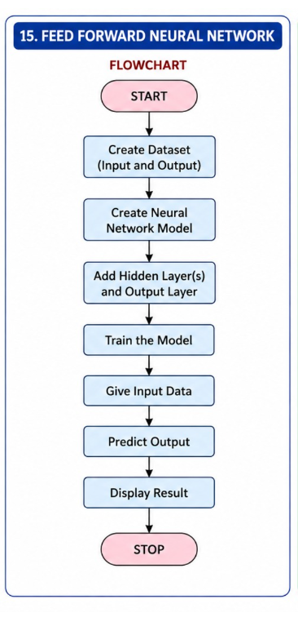

Code
from sklearn.neural_network import MLPClassifier
X = [[0,0], [0,1], [1,0], [1,1]]
y = [0, 1, 1, 0]
model = MLPClassifier(
hidden_layer_sizes=(4,),
max_iter=2000,
random_state=1
)
model.fit(X, y)
print("Predictions:", model.predict(X))
Output
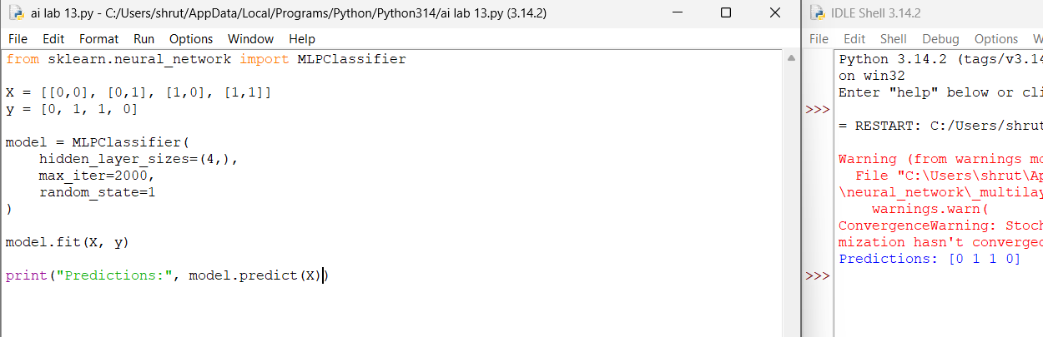

Result
Predictions: [0 1 1 0]
Conclusion
Thus, the Feed Forward Neural Network was successfully implemented using Python.

